Zach Smith
Network+ part 2
Windows firewall lab

Step 1:
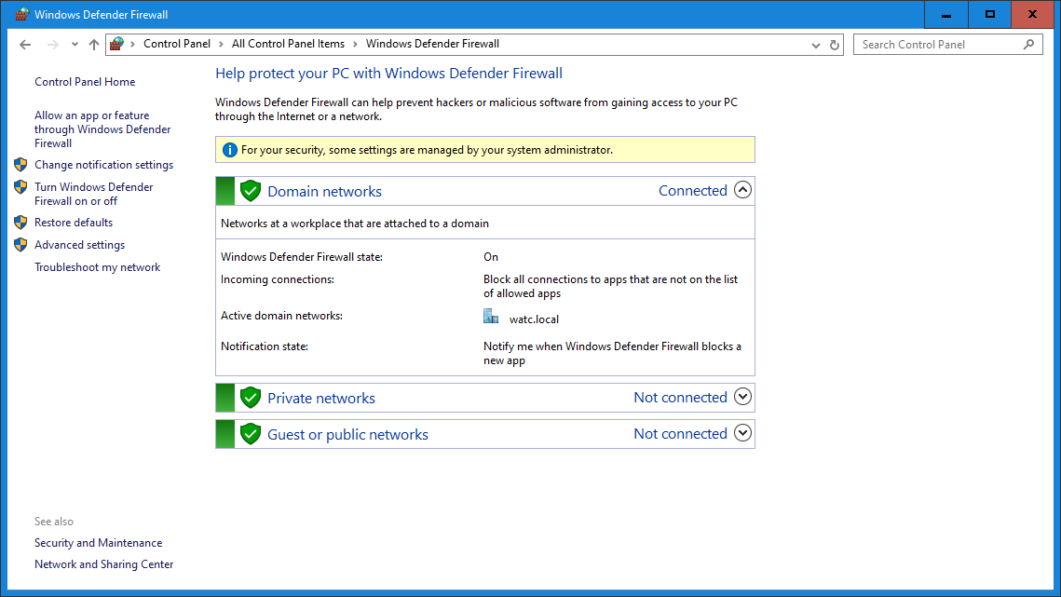

Step 2:
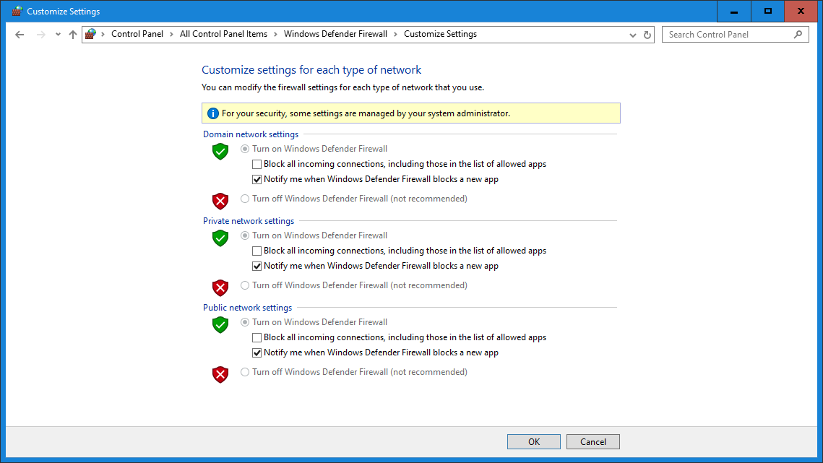
Step 3:
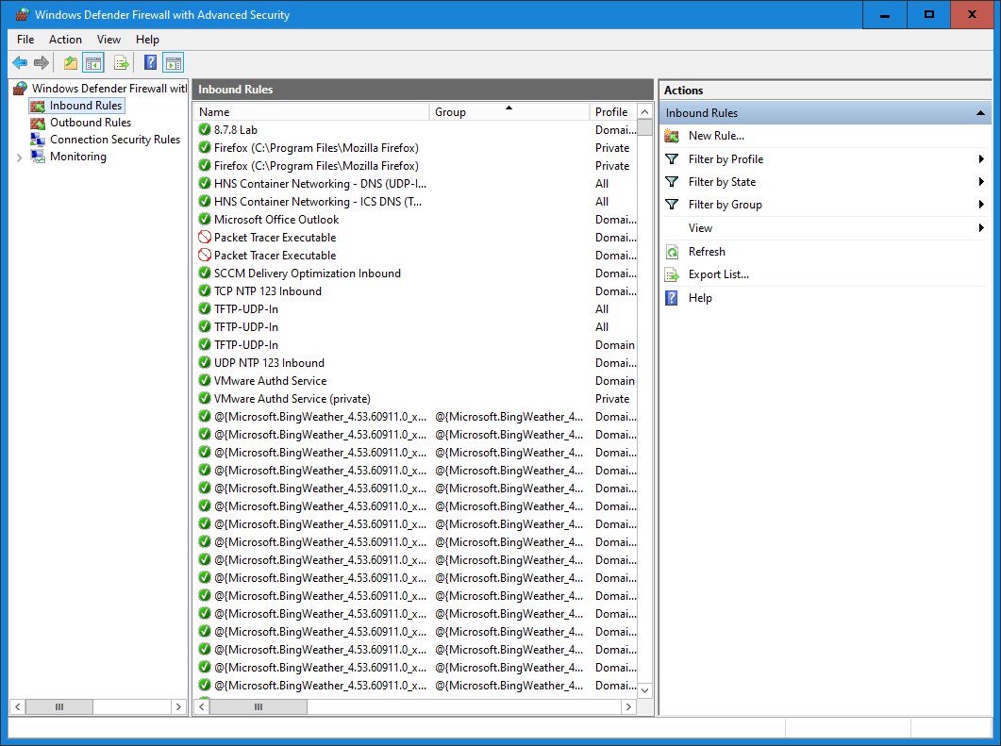

Step 4:
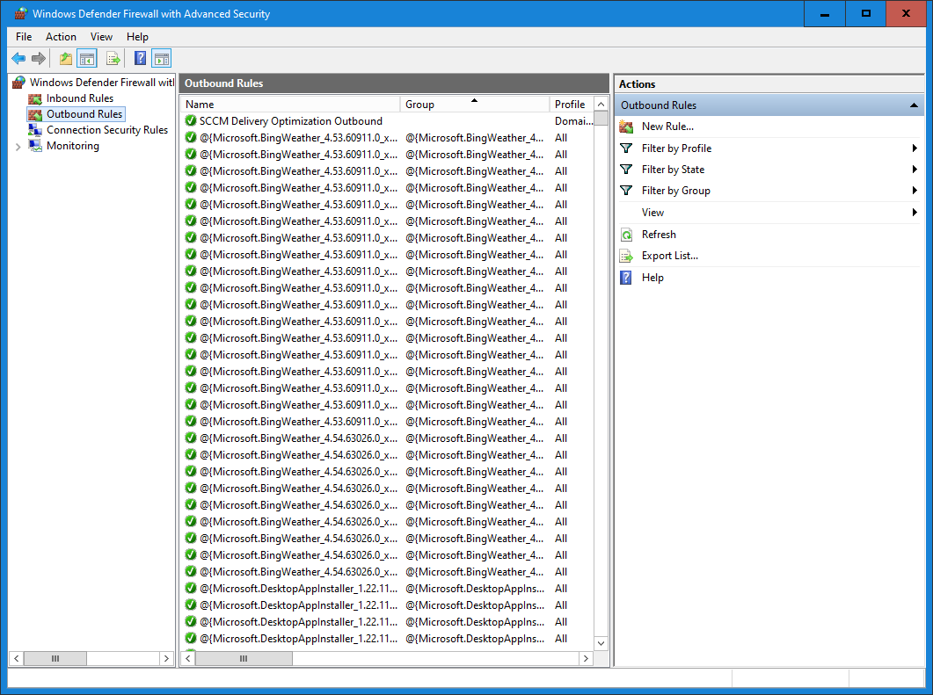
Step 5:
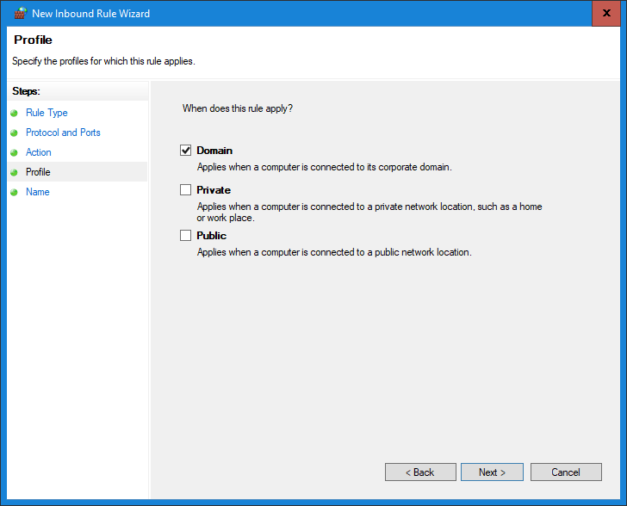
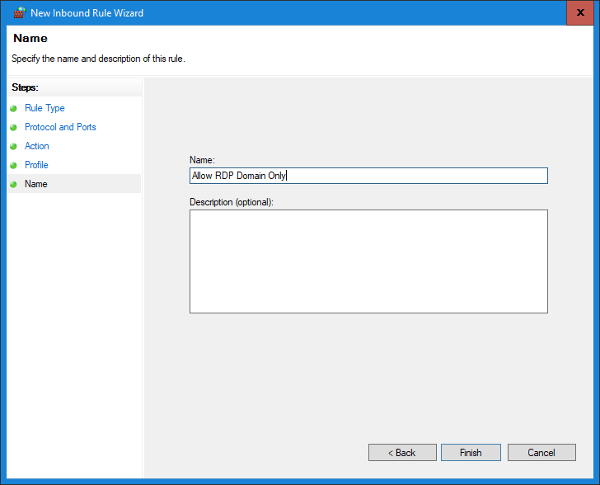
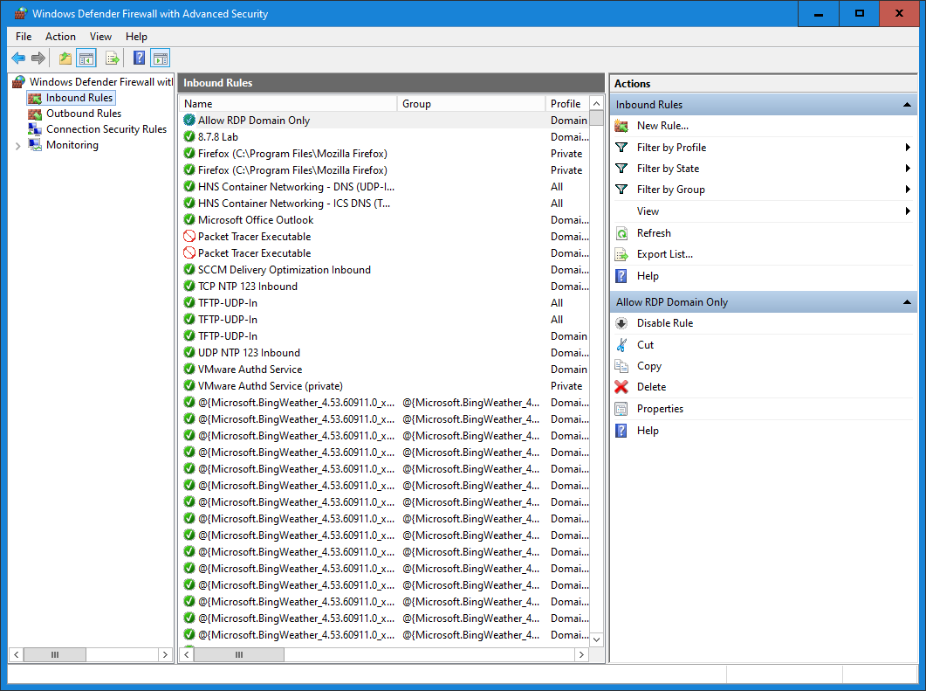
Step 6:
Not available.
Step 7:
Could not find logging in any of the settings for monitoring -> firewall
Reflection questions:
- Different profiles are important since the machine may not always be connected to a secure network. You don’t want to allow RDP when connected to mcdonalds wifi for example.
- If you allow all inbound traffic that exposes you to more security threats.
- Outbound rules will prevent data breaches by disallowing common data export methods. Can’t set up an FTP server if your machine isn’t allowed to send over ftp.
- You have to test them or else you can’t verify that the holes are closed. If a firewall rule is misconfigured then it may block all traffic or block none.
- Firewall logging will help to monitor attack vectors and sources.

